# Grazio Salvare Rescue-Dogs Dashboard README

## About the Project/Project Title

The Grazioso Salvare Rescue-Dogs Dashboard is an interactive data dashboard for Grazioso Salvare to identify and categorize dogs that are good candidates for search-and-rescue training. The dashboard connects to a MongoDB database, retrieves animal shelter outcome data, and provides intuitive visualizations through interactive filters, tables, a pie chart, and a geolocation map.

## Motivation

The goal of this project is to create a user-friendly , dynamic web application that allows a user to quickly find dogs suitable for specific rescue operations, based on breed, age, and sex criteria. The dashboard reduces manual search efforts and displays data in an intuitive way to support better decision making.

## Getting Started

1. Ensure that Python and Jupyter Notebook are both installed on your device.
2. Run the ProjectTwoDashboard.ipnyb file inside Jupyter Notebook.
3. Open the link provided.

## Installation

* Python 3.10+
* pymongo
* local MongoDB
* Jupyter Notebook

## Usage

Use the filter options (radio buttons) to select:

* Water Rescue
* Mountain or Wilderness Rescue
* Disaster or Individual Tracking
* Reset (view all animals)

Select a dog in the table to update the geolocation map.

View breed distribution in the updated pie chart dynamically.

### Code Example

Below is a code example of the query used for the Water Rescue radio button. This MongoDB query retrieves intact female dogs of selected breeds, aged between 26 to 156 weeks, ideal for Water Rescue training.

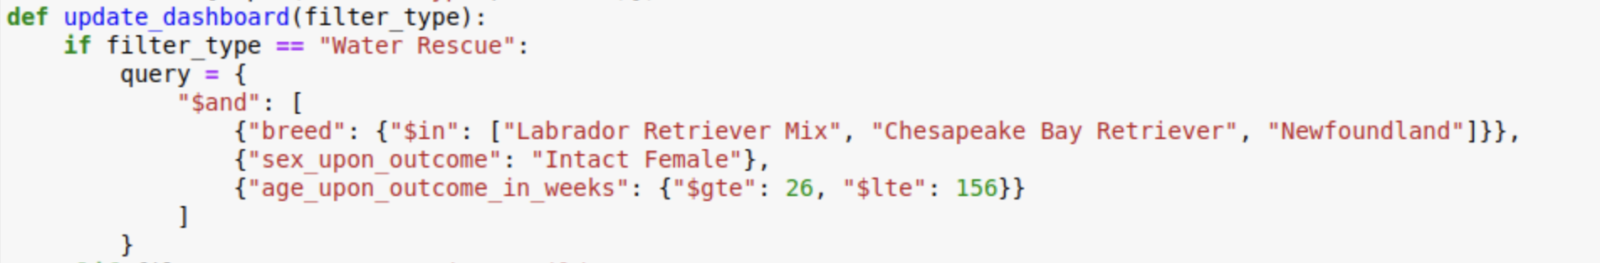

### Tests

Testing for this project was done manually through the following steps:

* Verifying that the radio buttons update the table, pie chart, and the geolocation map.
* Confirming that the reset button restores all of the data from the entire dataset.
* Ensuring that the selection of another row changed the location shown on the map.
* Testing to ensure different scenarios don’t cause bugs or unexpected errors.

### Screenshots

The following screenshots show that the full functional requirements have been met for the Dashboard. Those being:

* The Grazioso Salvare logo and unique identifier are seen on the webpage.
* Interactive filter options are available to filter the data for best dogs for certain types of rescue.
* Filter the data dynamically to update the table when a filter is selected.
* Display an interactive data table of data.
* Display a dynamic chart that changes based off of the selected filter.
* Display a dynamic geolocation map that changes dependent on the row element selected in the data table
* Reset button returns table, chart and map to default state.

The following screenshots will reflect these requirements.

Reset filter selected:

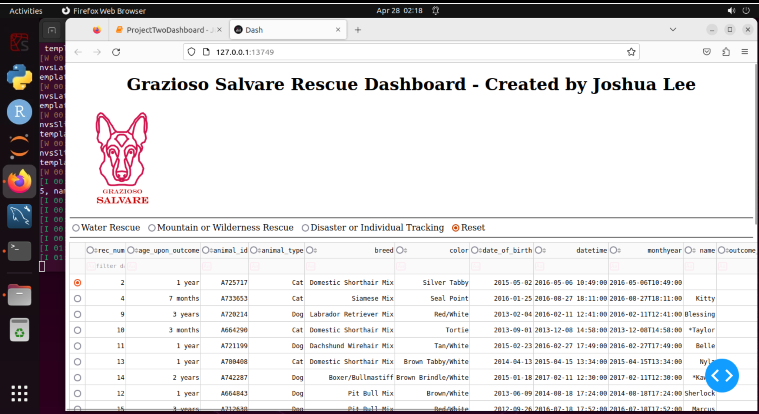

Mountain or Wilderness Rescue filtered search:

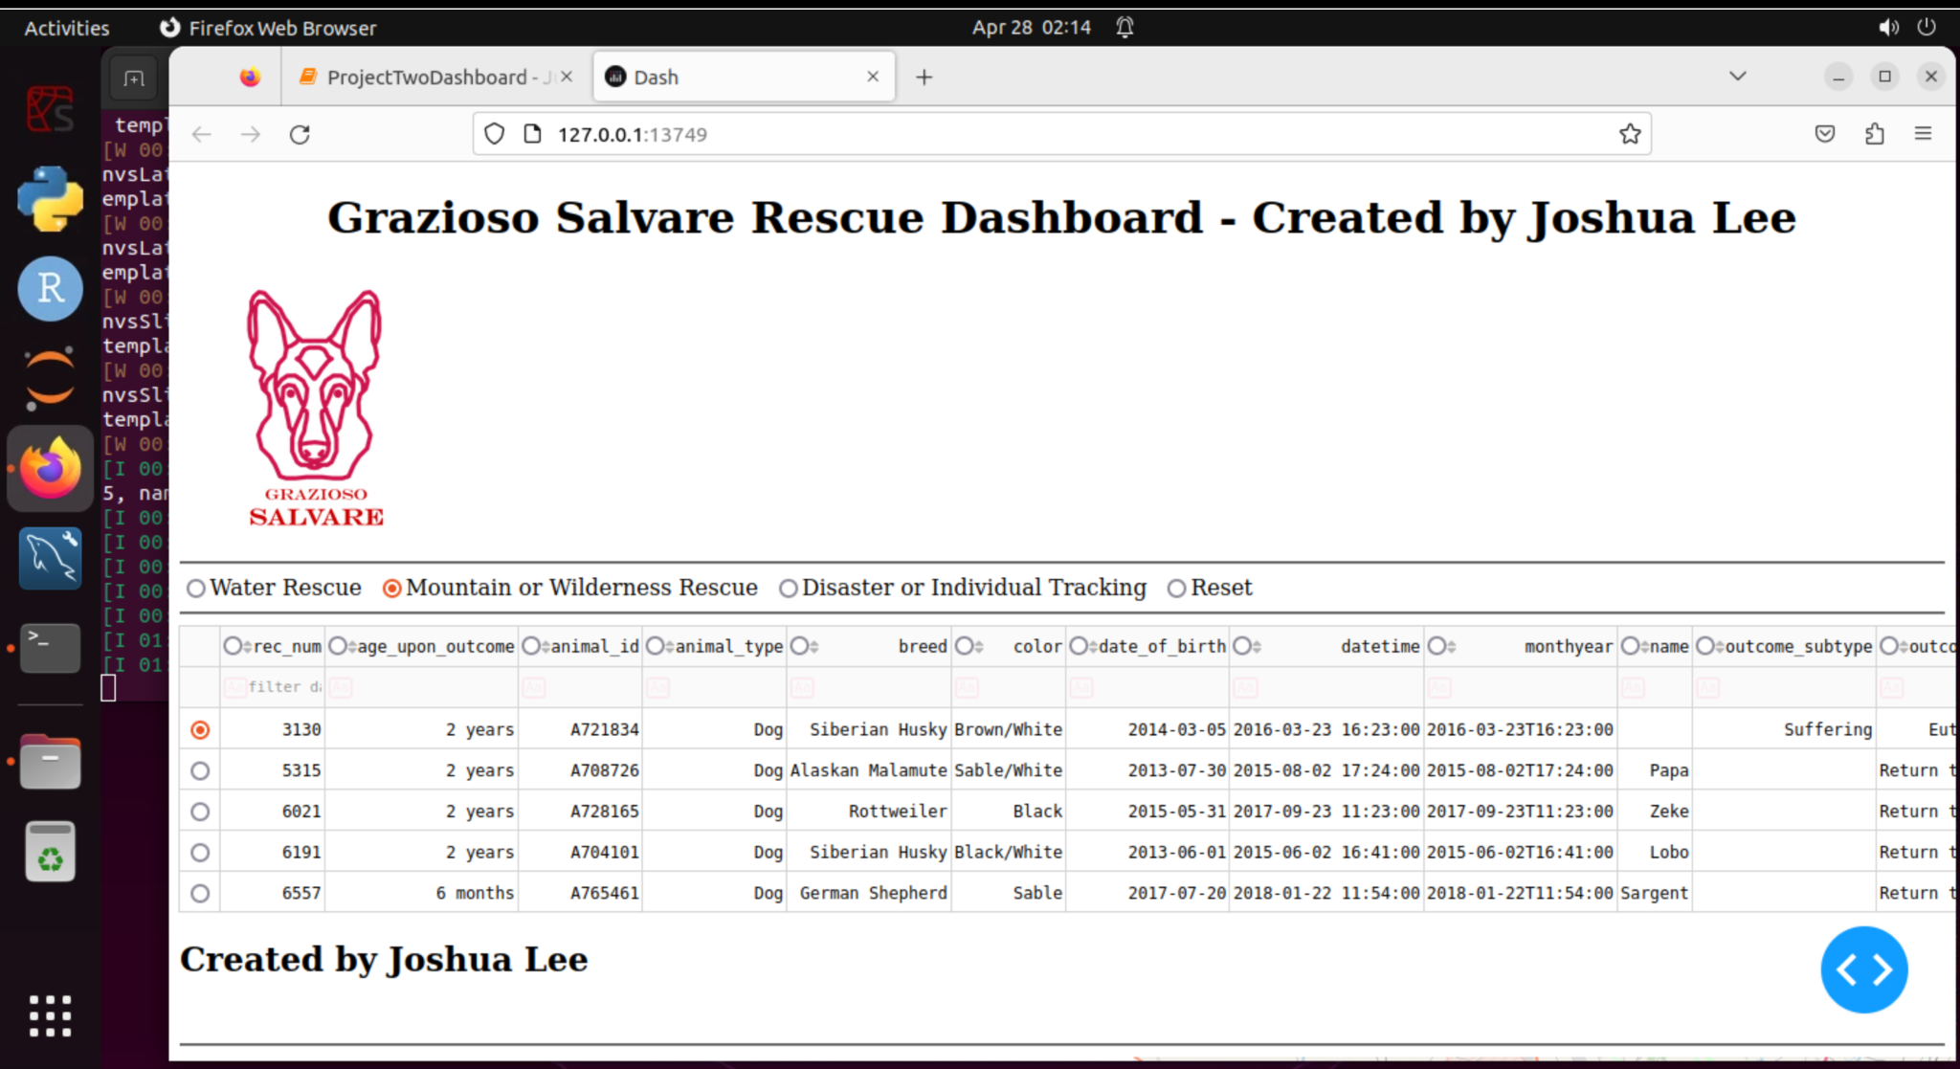

Water rescue filtered search:

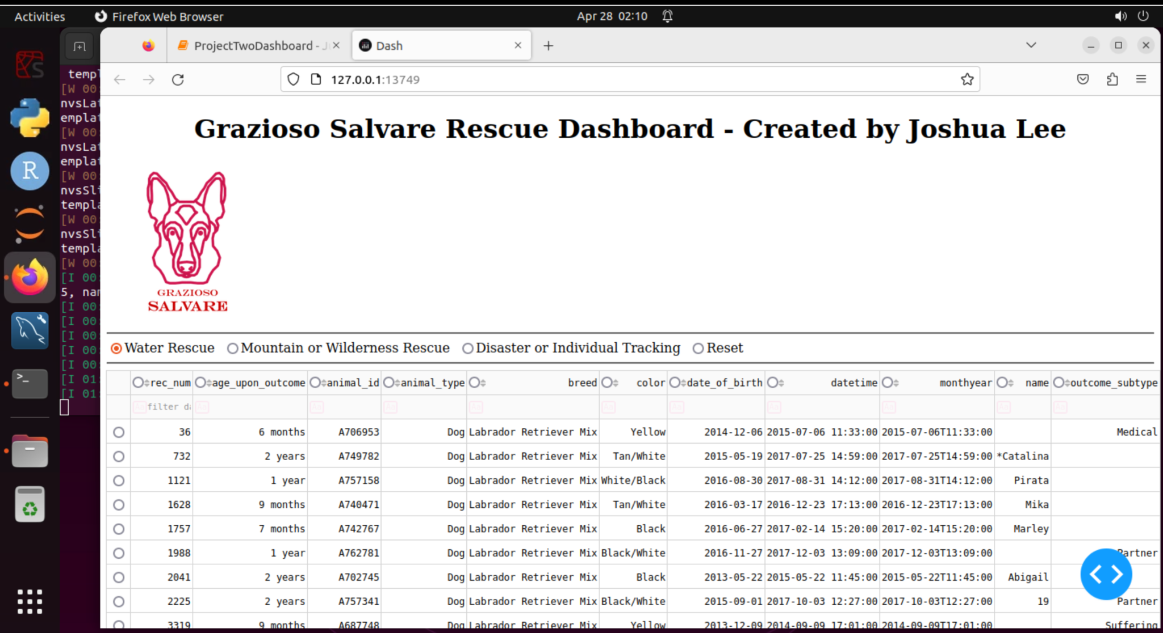

Disaster or individual tracking filtering option:

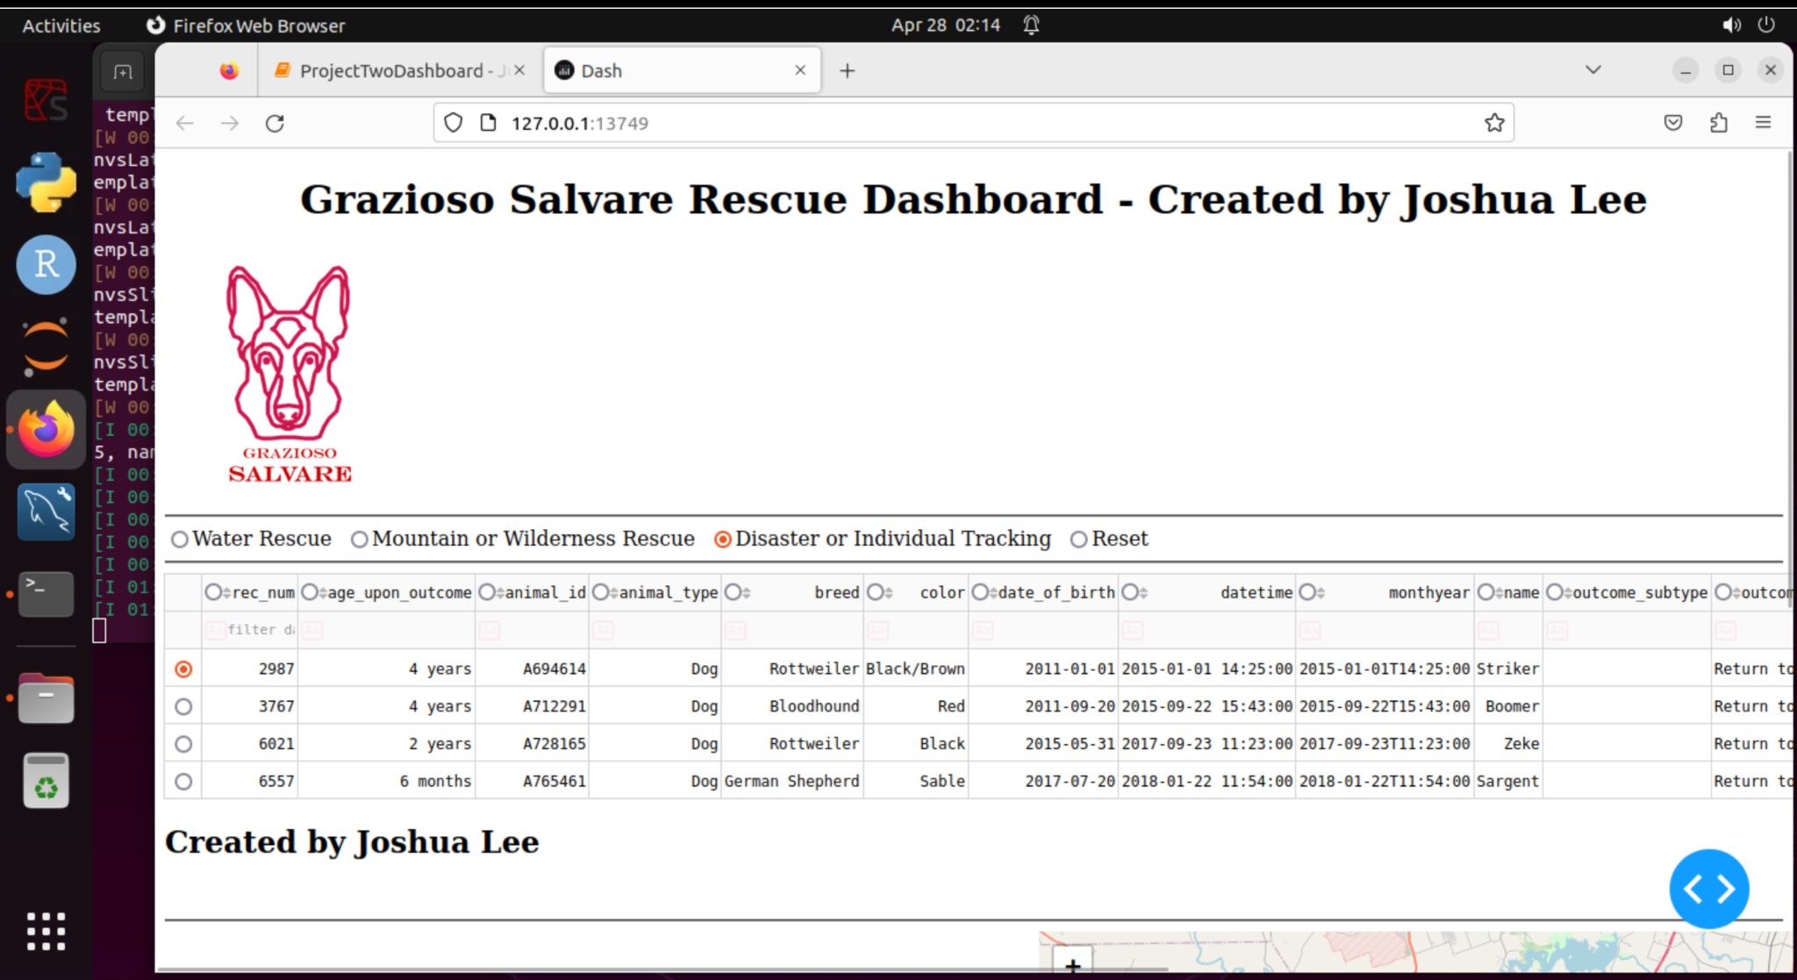

Reset pie chart:

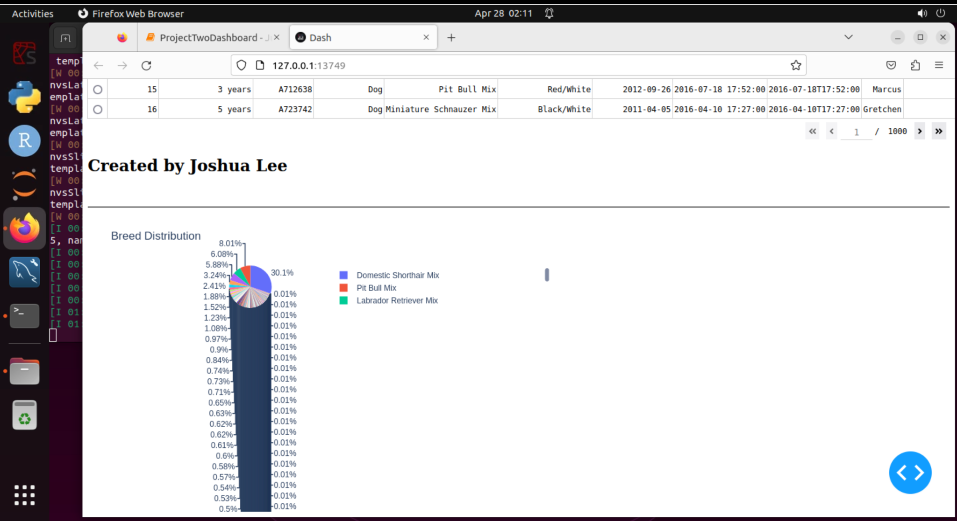

Water rescue pie chart:

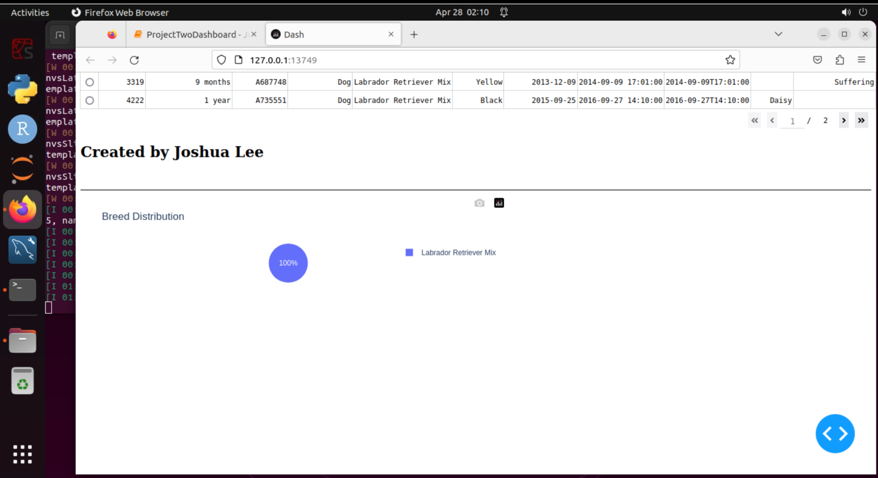

Map results of row 16:

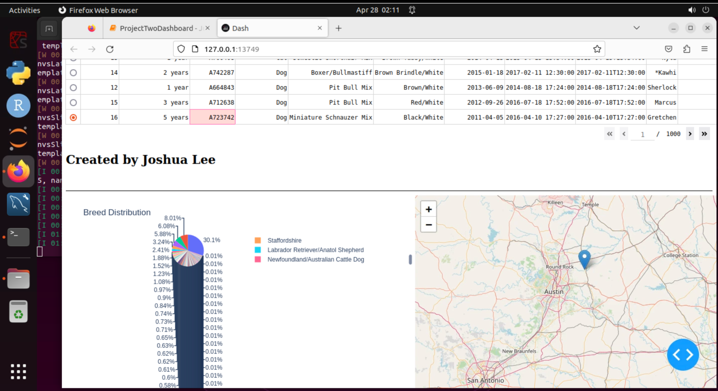

Map results of an alternative row:

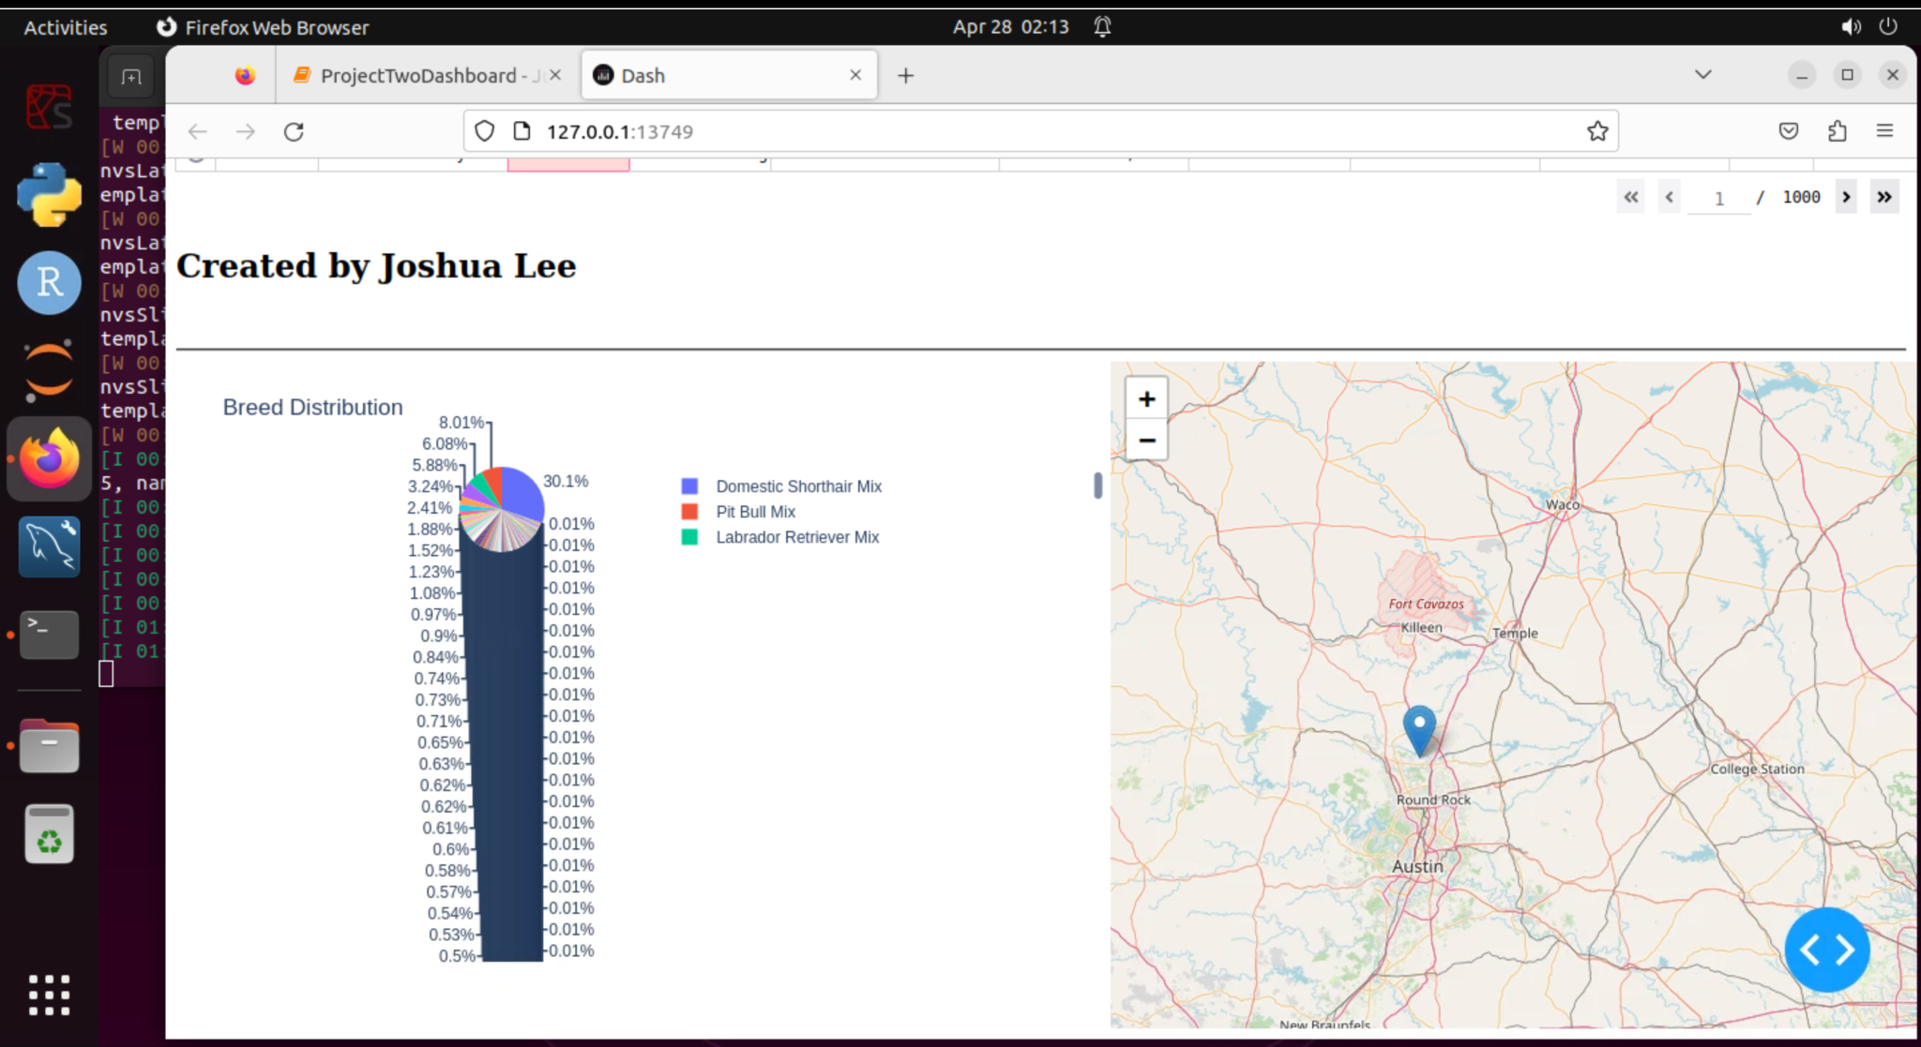

## Contact

Your name: Joshua Lee